PROJECT REPORT TEMPLATE

1. INTRODUCTION

1.1 OVERVIEW

YouTube Analytics gives you high-level summary of how your channel and videos are performing on YouTube. The key metrics card shows your views, watch time, subscribers, and estimated revenue.

1.2 PURPOSE

The purpose of YouTube is to share videos with people all over the world. They can share anything from funny videos to promotions for businesses.

2. PROBLEM DEFINITION & DESIGH THINKING

2.1 EMPATHY MAP

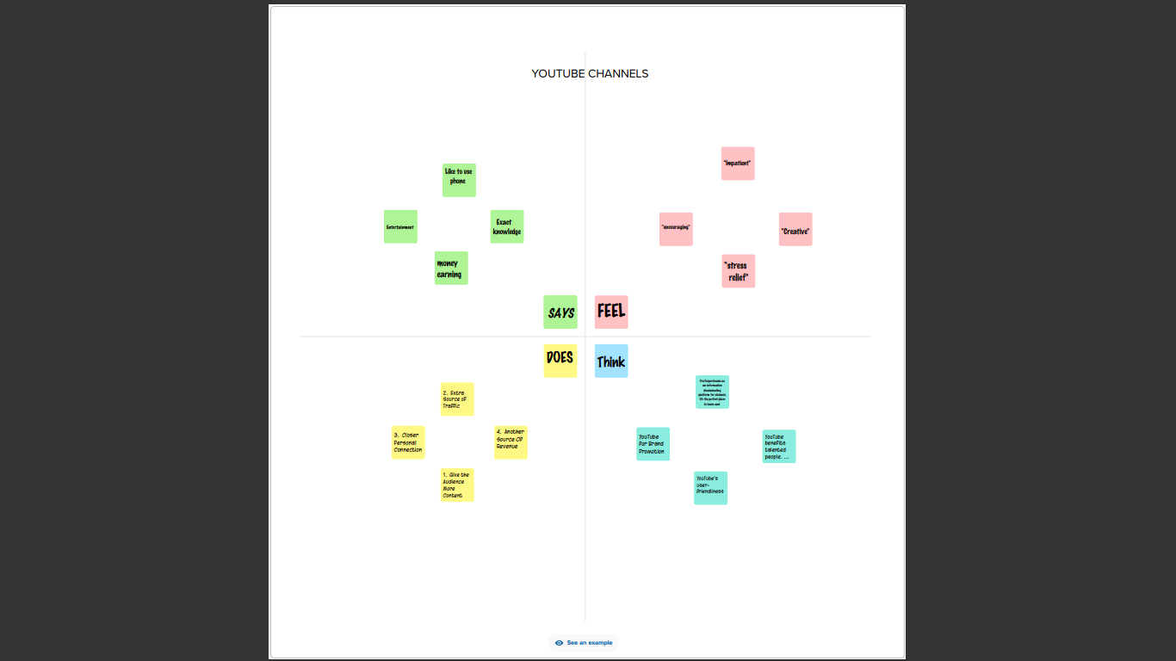

2.2 IDEATION & BRAINSTROMING MAP

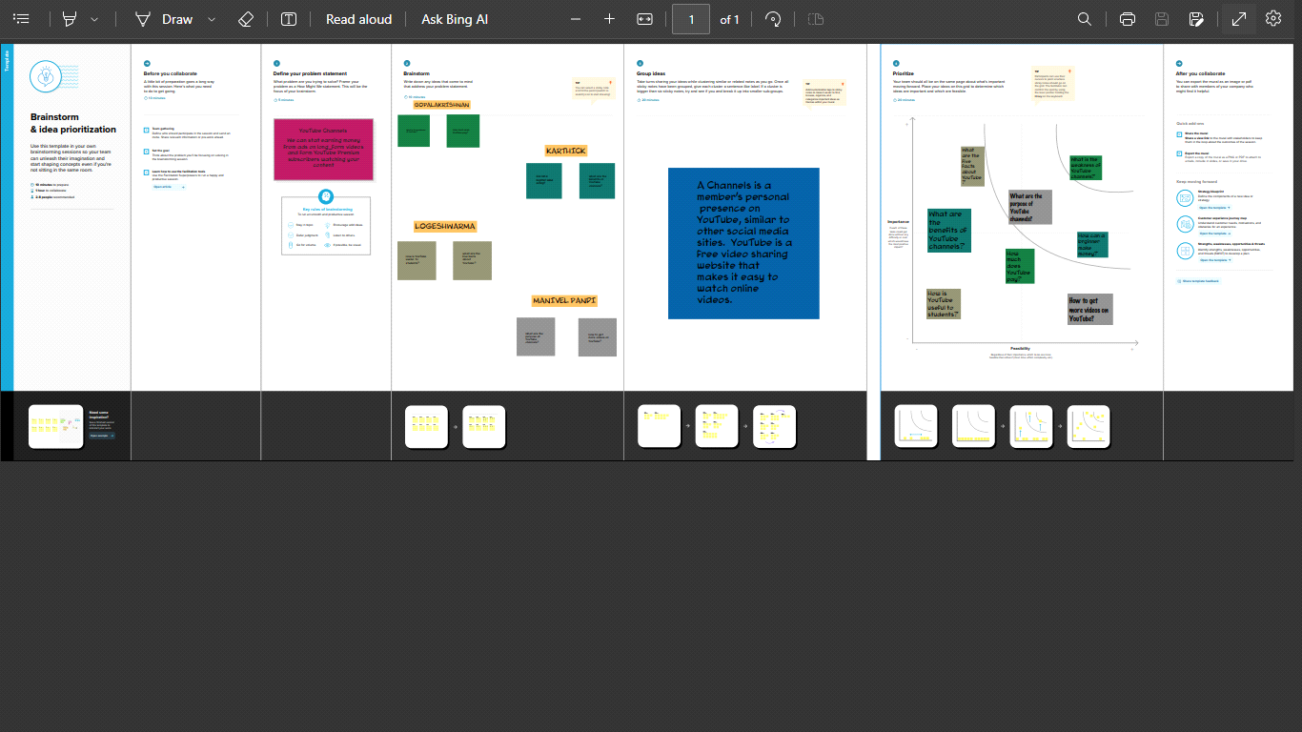

3. RESULT

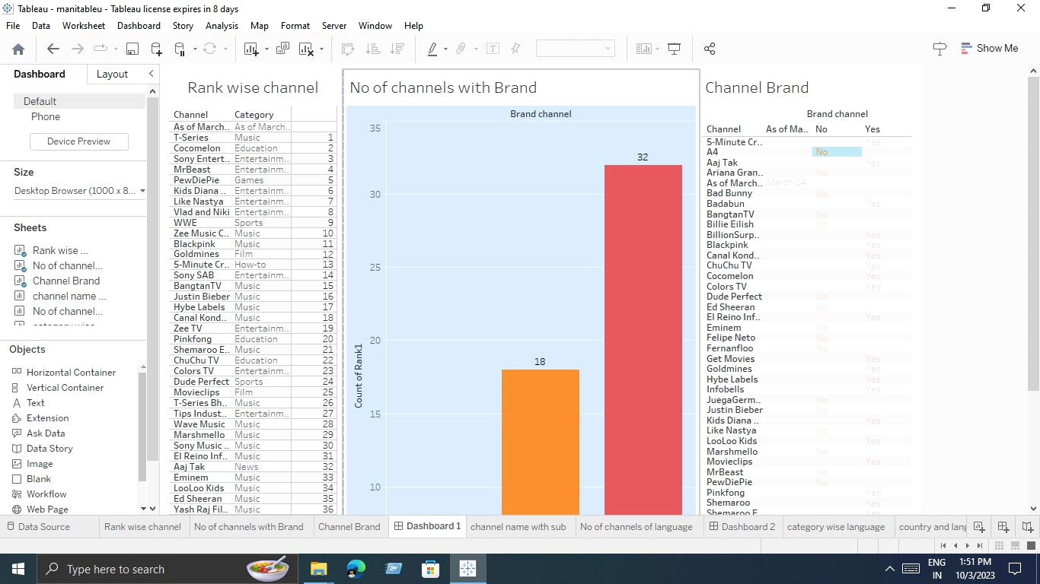

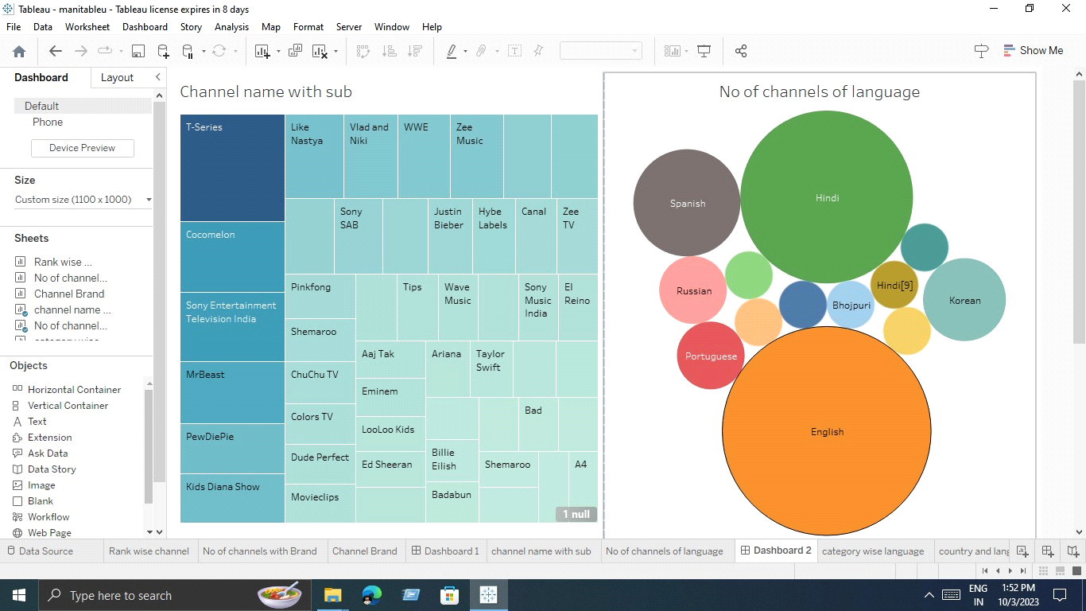

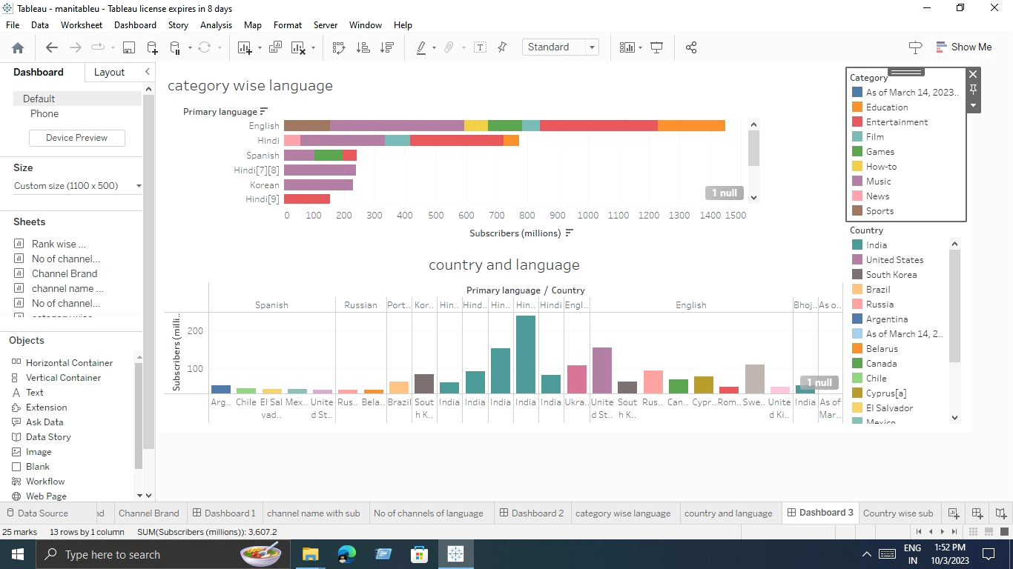

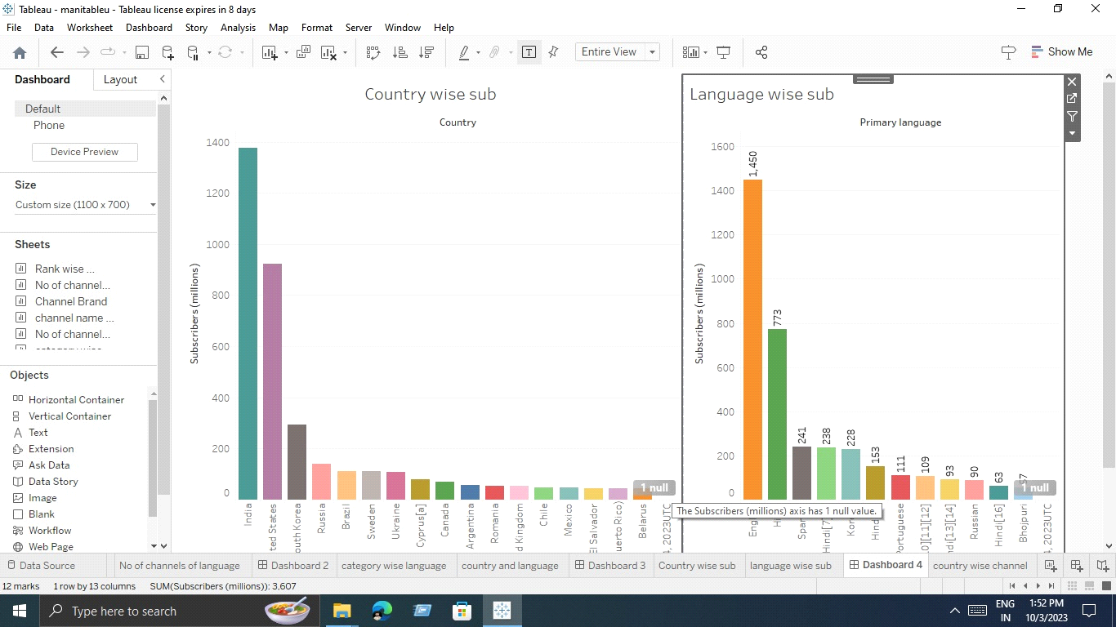

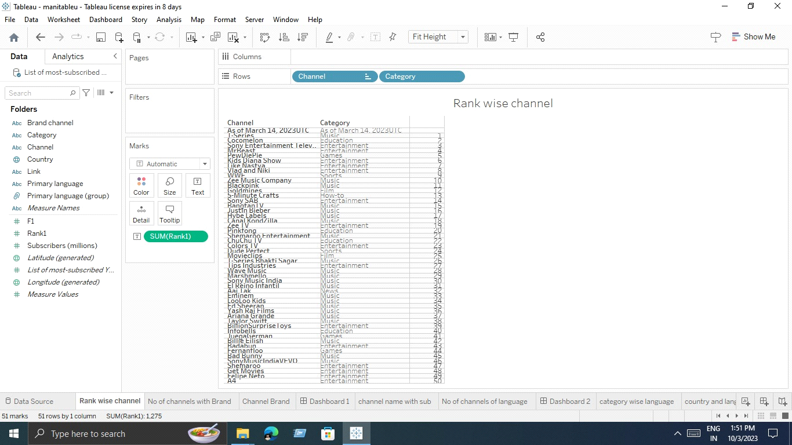

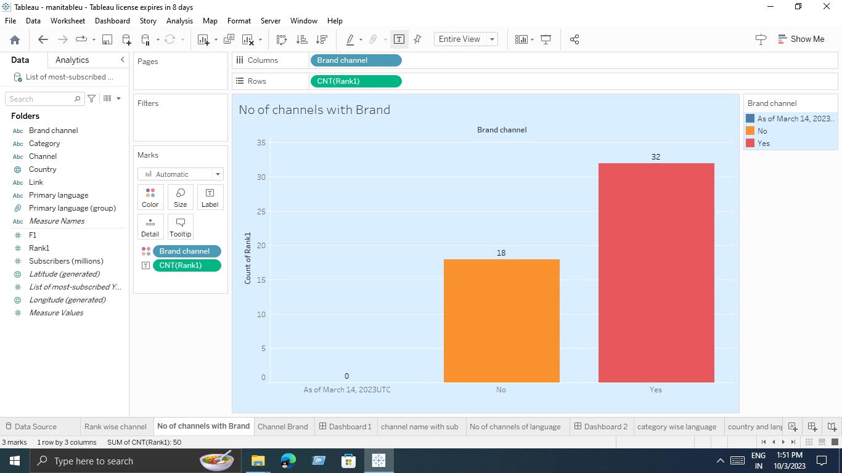

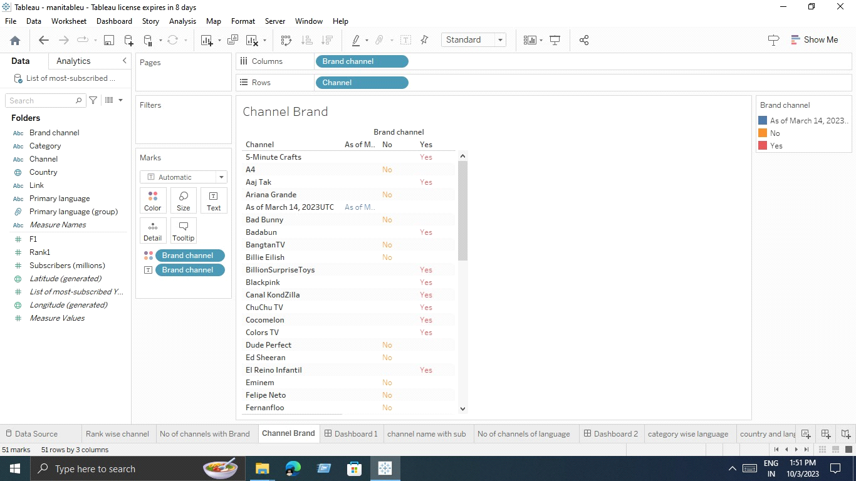

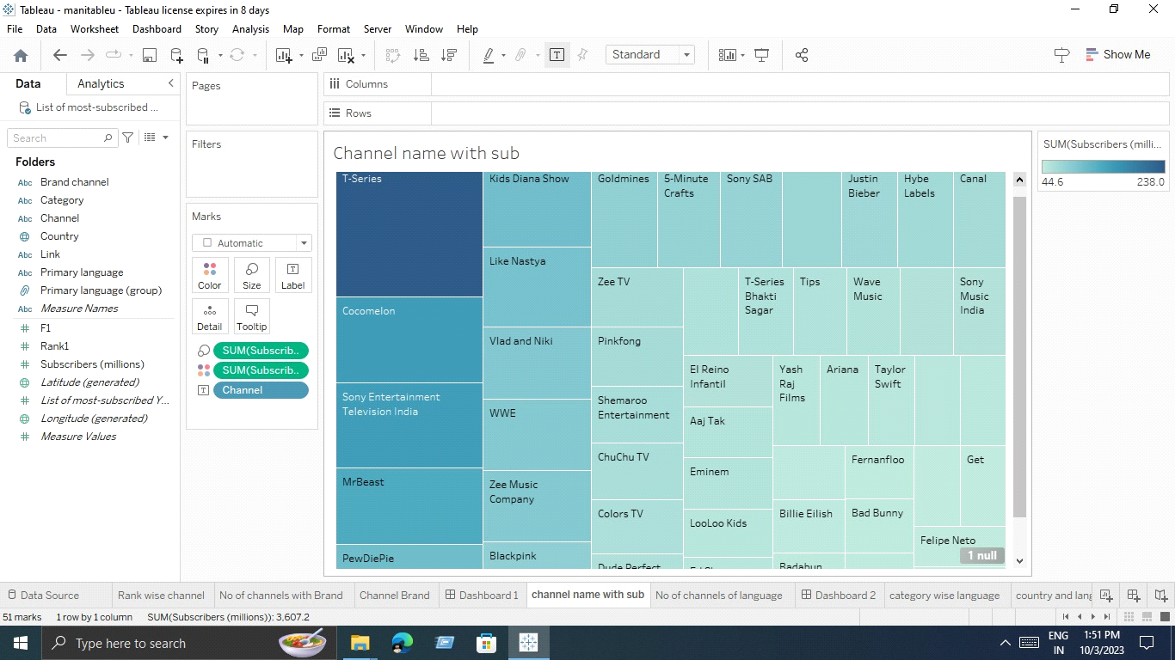

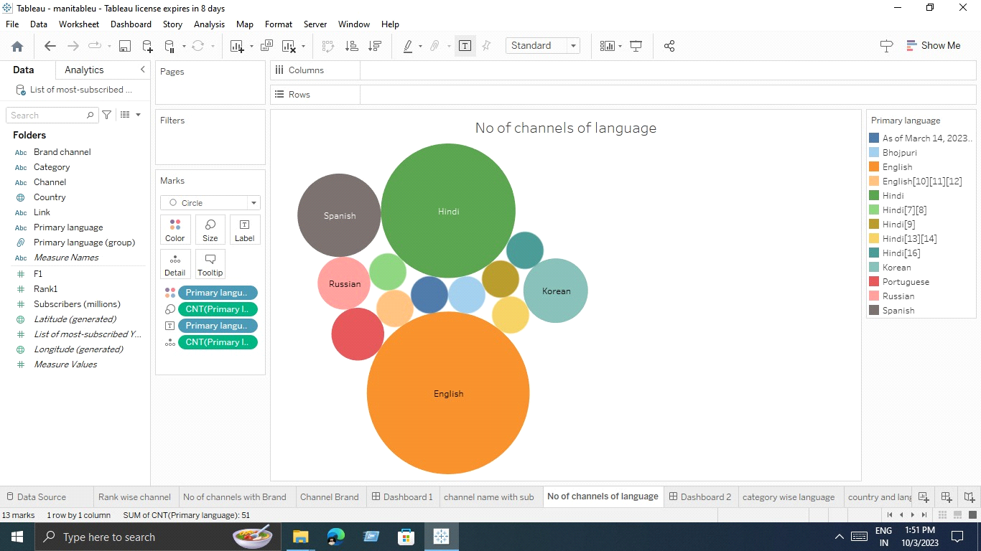

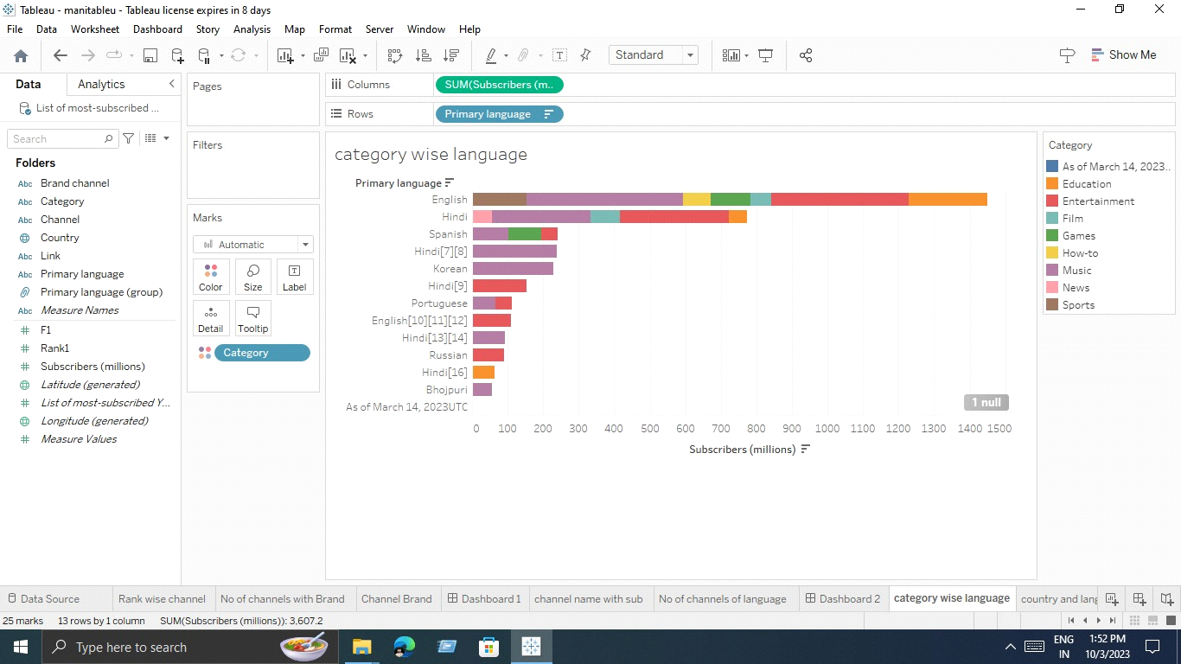

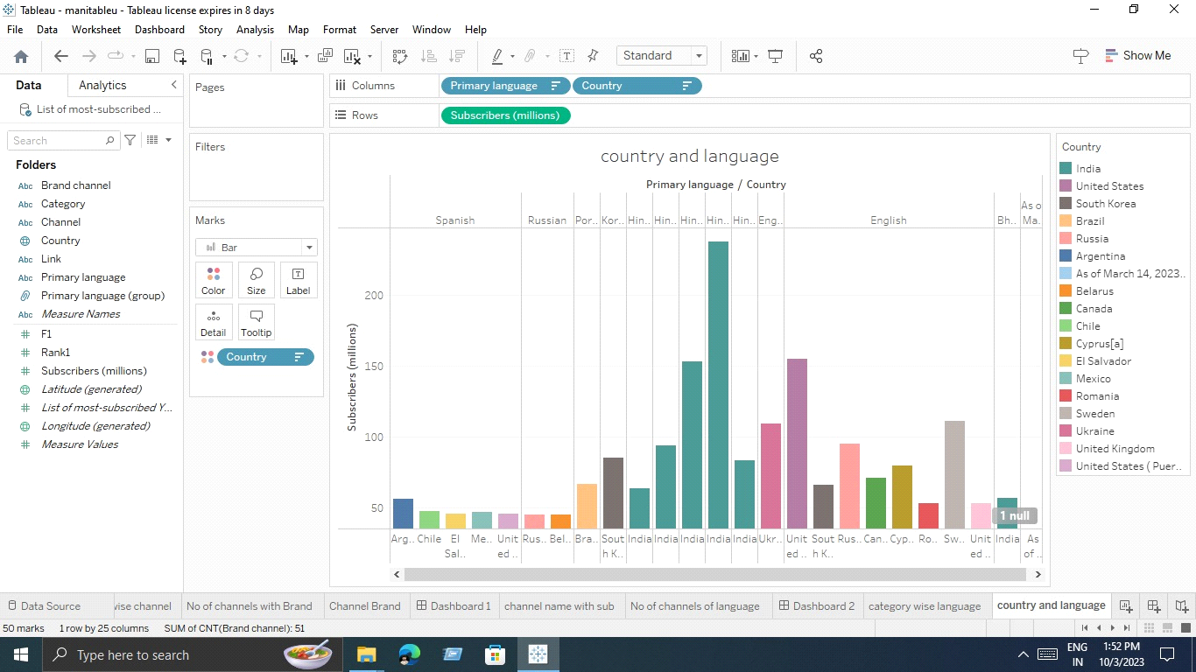

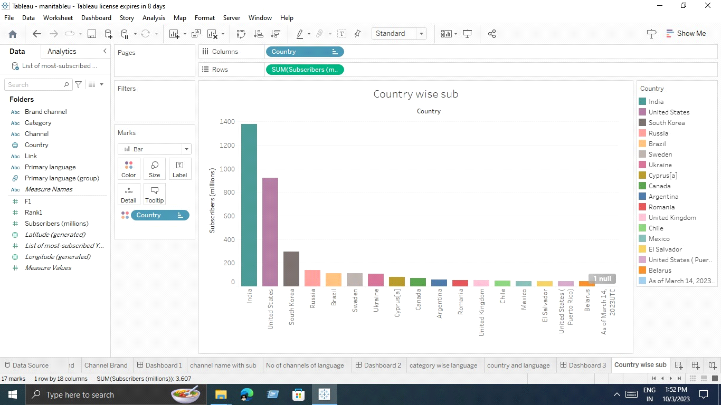

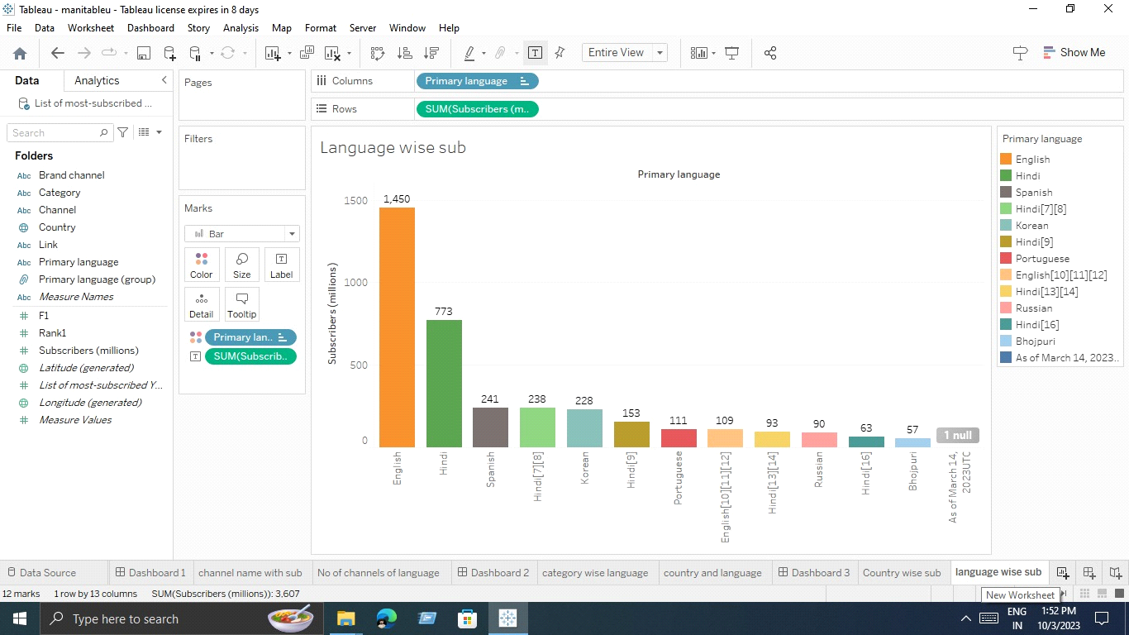

4. ADVANTAGES & DISADVANTAGES

ADVANTAGES

You Tube as an information disseminating platform for students. It's perfect place to learn and gain expertise.

DISADVANTAGES

Creating compelling content.

Reaching audience on a large scale.

5. APPLIATIONS

YouTube is a video sharing service where users can watch, like, share, comment and upload their own videos.

6. CONCLUSION

YouTube is a social platform that allows for two way communication between brands and their audience.

7. FUTURE SCOPE

YouTube will become an all-encompassing entertainment service, where you can watch videos, listen to music, and play games.